**Random Forest**

**1º corrida**

|  |  |  |
| --- | --- | --- |
| **CONTROLES** | **NTREE** | **MTRY** |
| **1** | 500 | 7 |
| **2** | 500 | 5 |
| **3** | 500 | 6 |
| **4** | 550 | 6 |
| **5** | 450 | 7 |
| **6** | 450 | 6 |

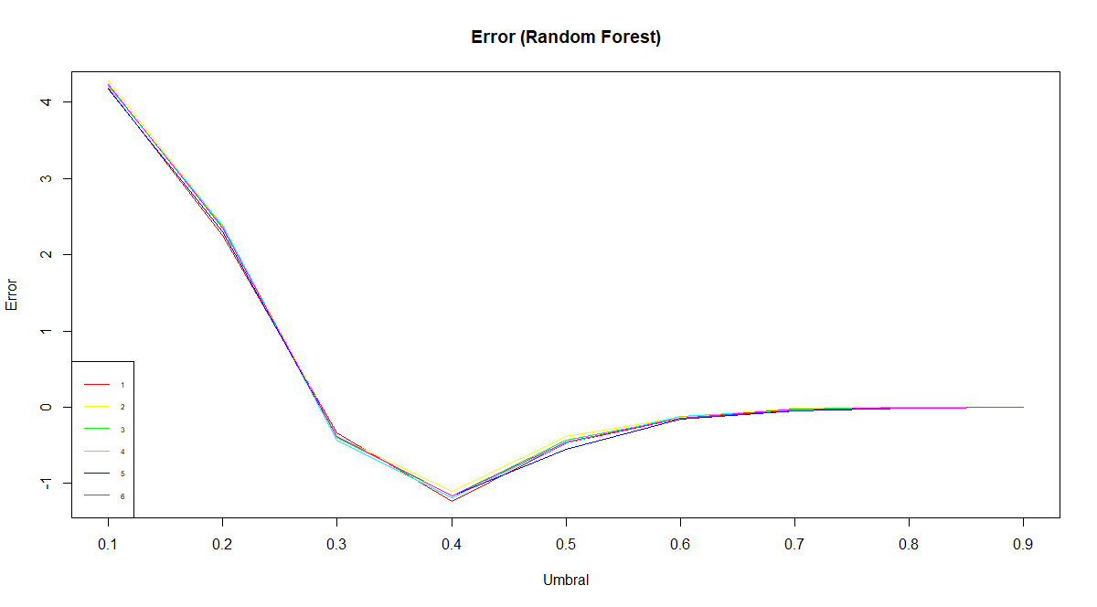

|  |  |  |  |  |  |  |  |  |  |
| --- | --- | --- | --- | --- | --- | --- | --- | --- | --- |
|  | UMBRALES | | | | | | | | |
| **CONTROLES** | **0,1** | **0,2** | **0,3** | **0,4** | **0,5** | **0,6** | **0,7** | **0,8** | **0,9** |
| **1** | 4,182 | 2,253 | -0,330 | **-1,228** | -0,467 | -0,146 | -0,038 | -0,011 | 0,000 |
| **2** | 4,278 | 2,371 | -0,381 | -1,103 | -0,387 | -0,129 | -0,016 | 0,000 | 0,000 |
| **3** | 4,218 | 2,361 | -0,389 | -1,157 | -0,432 | -0,137 | -0,020 | 0,000 | 0,000 |
| **4** | 4,209 | 2,390 | -0,427 | **-1,188** | -0,467 | -0,123 | -0,035 | -0,004 | 0,000 |
| **5** | 4,170 | 2,302 | -0,381 | -1,163 | -0,554 | -0,154 | -0,046 | -0,007 | 0,000 |
| **6** | 4,238 | 2,356 | -0,389 | -1,157 | -0,452 | -0,146 | -0,026 | -0,007 | 0,000 |

**2º corrida**

|  |  |  |
| --- | --- | --- |
| **CONTROLES** | **NTREE** | **MTRY** |
| **1** | 550 | 6 |
| **2** | 550 | 7 |
| **3** | 600 | 5 |
| **4** | 600 | 6 |
| **5** | 600 | 7 |

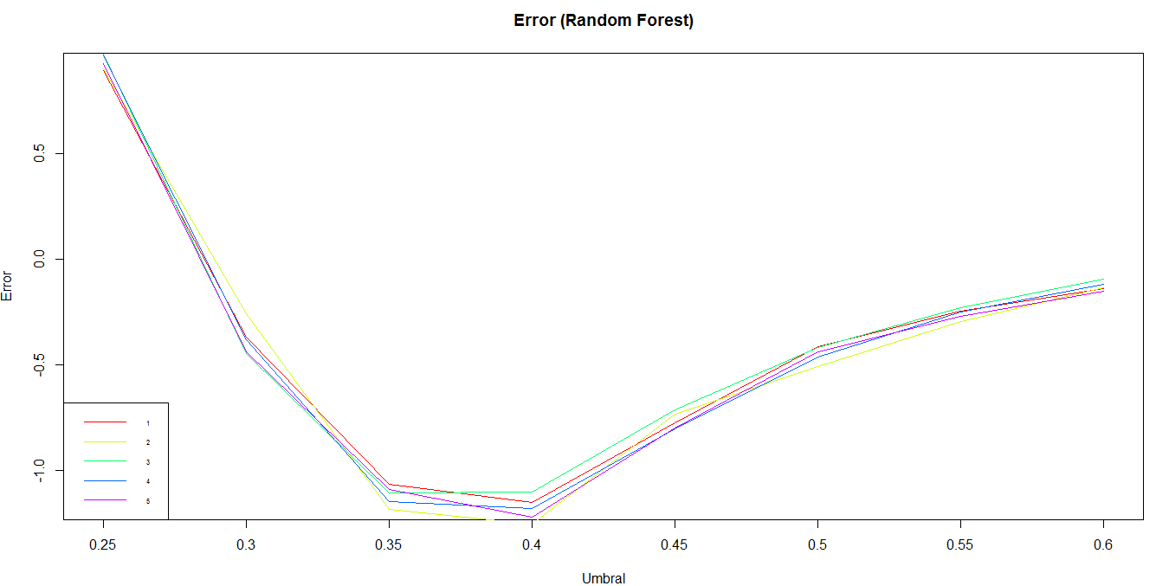

|  |  |  |  |  |  |  |  |  |
| --- | --- | --- | --- | --- | --- | --- | --- | --- |
|  | UMBRALES | | | | | | | |
| **CONTROLES** | **0,25** | **0,3** | **0,35** | **0,4** | **0,45** | **0,5** | **0,55** | **0,6** |
| **1** | 0,894 | -0,367 | -1,068 | -1,151 | -0,776 | -0,416 | -0,244 | -0,139 |
| **2** | 0,903 | -0,259 | -1,187 | **-1,255** | -0,733 | -0,507 | -0,294 | -0,133 |
| **3** | 0,972 | -0,448 | -1,107 | -1,102 | -0,715 | -0,420 | -0,230 | -0,094 |
| **4** | 0,966 | -0,380 | -1,147 | -1,181 | -0,806 | -0,462 | -0,250 | -0,118 |
| **5** | 0,927 | -0,438 | -1,090 | **-1,223** | -0,800 | -0,440 | -0,270 | -0,152 |

**3º corrida**

|  |  |  |
| --- | --- | --- |
| **CONTROLES** | **NTREE** | **MTRY** |
| **1** | 550 | 7 |
| **2** | 600 | 6 |
| **3** | 600 | 7 |
| **4** | 600 | 8 |
| **5** | 700 | 7 |



|  |  |  |  |  |  |  |
| --- | --- | --- | --- | --- | --- | --- |
|  | **UMBRALES** | | | | | |
| **CONTROLES** | **0,32** | **0,34** | **0,36** | **0,38** | **0,4** | **0,42** |
| **1** | -0,736 | -1,020 | -1,107 | -1,240 | -1,215 | -1,101 |
| **2** | -0,728 | -1,071 | -1,190 | -1,198 | -1,164 | -0,997 |
| **3** | -0,690 | -0,866 | -1,216 | **-1,306** | -1,256 | -1,062 |
| **4** | -0,659 | -0,996 | -1,175 | -1,203 | -1,275 | -1,225 |
| **5** | -0,865 | -0,993 | -1,164 | **-1,336** | -1,203 | -1,069 |

[[3]]

Call:

Type of random forest: classification

Number of trees: 600

No. of variables tried at each split: 7

OOB estimate of error rate: 28.24%

Confusion matrix:

0 1 class.error

0 26069 546 0.02051475

1 10028 802 0.92594645

[[5]]

Call:

Type of random forest: classification

Number of trees: 700

No. of variables tried at each split: 7

OOB estimate of error rate: 28.37%

Confusion matrix:

0 1 class.error

0 26073 542 0.02036446

1 10080 750 0.93074792

Se realiza CrossValidation para los Control y Umbral de probabilidad que dieron error más bajo con la función de costo.

Error h1 - umbral: 0.38 test: -1.306321 cv: -1.142743

Error h2 - umbral: 0.38 test: -1.336216 cv: -1.167179